W O R K S H E E T

Exercise 1: Culture vocabulary. Write the words under the correct picture.
Porcelain [‘poselɪn] | Pilaster [pɪ’læstə] | Coat-of-arms
Capital [‘kæpɪtl] | 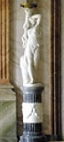  Candelabrum [kændɪ’lɑ:brəm] | 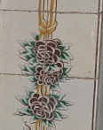  Tile

Exercise 2: Match the two parts of the sentences below together.

Mural  Plafond  Grisaille | (French for 'grey') a term for painting, usually in shades of grey imitating of relief sculpture  a painting or other work of art executed directly on a wall /fresco, wall-painting/  (French for ‘ceiling’) monumental and decorative painting in the palace staterooms, /ceiling-picture/

W O R K S H E E T

Exercise 3: Culture vocabulary. Write the words under the correct picture.
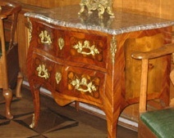  Chest of drawers | 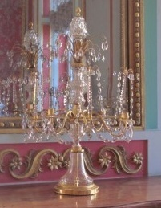  Girandole | Console [‘kɔnsəul]
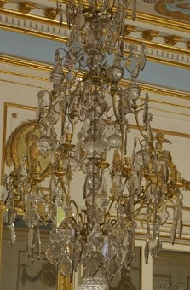  Chandelier | 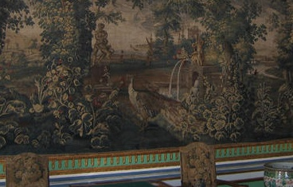  Tapestry [‘tæpɪstrɪ] | Sconce [skɔns]

Exercise 4: Write the words in the appropriate section of the table below.

Furniture  chest of drawers  bureau  console  sewing table | Lighting Devices  sconce  candelabrum  crystal lamp  chandelier | Painting  mural  grisaille  plafond  still life  self-portrait

W O R K S H E E T
Exercise 5: Complete sentences with words and expressions from the box.
1. Kuskovo is the summer countryside residence of Count Pyotr Sheremetev.
2. Each room in the palace has its own name, purpose, size and color .
3. The museum was founded in _____1919__________________________________________
4. Multicolored tiles stove demonstrate ______Russian traditions____________________ .
5. The palace was not intended ______for everyday life .
6. The State bedroom in the Kuskovo palace was built in imitation of _____ _____
the King’s chamber in Versailles.
7. The Kuskovo palace combined the European fashion and the Russian traditions .
8. The chandelier with crystal drops in the form of oak leaf is called ‘Leaf fall ‘ .
9. The ballroom in Kuskovo resembles the Hall of mirrors in Versailles.
10. Monogram PS is the initials in Latin of Pyotr Sheremetev .
H o m e t a s k:
In the 18th century Kuskovo nicknamed the Moscow Versailles. Visit the site of the Versailles museum and compare the Kuskovo museum and the Versailles museum.
 | K u s k o v o  www.kuskovo.ru | V e r s a i l l e s  www.chateauversailles.fr
Location | Russia | France
Date of construction | between 1740 and 1780 | The four building campaigns  (1664–1710)
The main building | The Palace | The Palace
Architect | under the direction of  Karl Blank | Louis Le Vau  Jules Hardouin-Mansart
The Park | Regular park | Regular park
Landscape architect |  | André Le Nôtre
The Palace interiors | The State Bedroom | The King's chamber
 | The White Dancing Hall | The Hall of mirrors
Exercise 6.

Imagine that you are a guide and visit the museum with your English friends. What can you tell them about Kuskovo?

________________________________________________________________________________________________________

_________________________________________________________________________________________________________

_________________________________________________________________________________________________________

_________________________________________________________________________________________________________

_________________________________________________________________________________________________________

_________________________________________________________________________________________________________

_________________________________________________________________________________________________________

_________________________________________________________________________________________________________

_________________________________________________________________________________________________________

_________________________________________________________________________________________________________

_________________________________________________________________________________________________________

_________________________________________________________________________________________________________

_________________________________________________________________________________________________________

_________________________________________________________________________________________________________

_________________________________________________________________________________________________________

_________________________________________________________________________________________________________

_________________________________________________________________________________________________________

_________________________________________________________________________________________________________

_________________________________________________________________________________________________________

_________________________________________________________________________________________________________

_________________________________________________________________________________________________________

_________________________________________________________________________________________________________

_________________________________________________________________________________________________________

