School ___________ Class________ Date ______________
Name _________________________Surname_____________________________

W O R K S H E E T С

Exercise 1: Read the description and find the name of the reception room.

The most elegant of the palace drawing rooms got its name from the bright pink color of its wall and furniture silk upholstery. _______________________________________

Exercise 2: Describe the exhibit using the words.
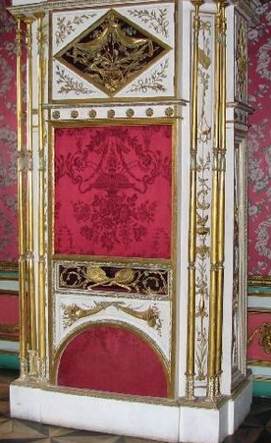 | O r g a n c h i k  It is a ________________________________________ similar to  _____________________, plays ___________________________.  The organ’s case is made from _________________ in the workshop of the famous __________________________________ Pavel Spol.  ● Moscow carver ● musical instrument ● wood ●  ● a barrel organ ● 18th century melodies ●

Exercise 3: Describe the exhibit.
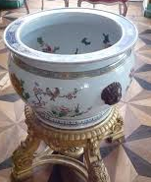 | A q u a r i u m  ________________________________________________________  ________________________________________________________  ________________________________________________________  _______________________________________________________  ● fish ● porcelain ● vase ● Aquarium ●China ● drawing inside ●

Exercise 4: Describe the portrait using the words.
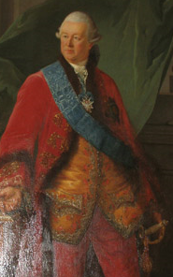 | The Portrait of Piotr Sheremetev, 1770–1772.  This canvas is one of museum’s masterpieces painted in __________ by _________________ French ________________Nicholas Benjamin Delapierre. The portrait depicts _______________of this country house.  It is the ____________________ portrait painted from nature. In the foreground of the picture the sitter is represented ________________ standing elegantly dressed in __________________ with the Order of the ______________________________the highest award in Russia.  From the Sheremetev ___________________________________.  ● St Andrew ● three quarter length ● ceremonial ● artist ● oils ●  ● collection ● red suit ● the master ● famous ●

Exercise 5: Describe the portrait.
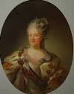 | The Portrait of Catherine II, 1779.  __________________________________________________________  _________________________________________________________  __________________________________________________________  _________________________________________________________  __________________________________________________________  __________________________________________________________  ● crown ● Empress ● three quarter length ● wreath laurel ● oils ●  ● unknown artist ● attributes of power ●  ● ceremonial ● ermine mantle ●

Exercise 6: Сhoose any picture in the Picture room. Describe the picture and offer to your friends to find it.
Useful phrases

portrait | the picture is executed  in bright (dark) tones | in the foreground
self-portrait | three quarter length | in the background
landscape | shoulder-length | to the left (right)  of the picture
still life | full-length | in the distance

