Raptors (birds of prey)
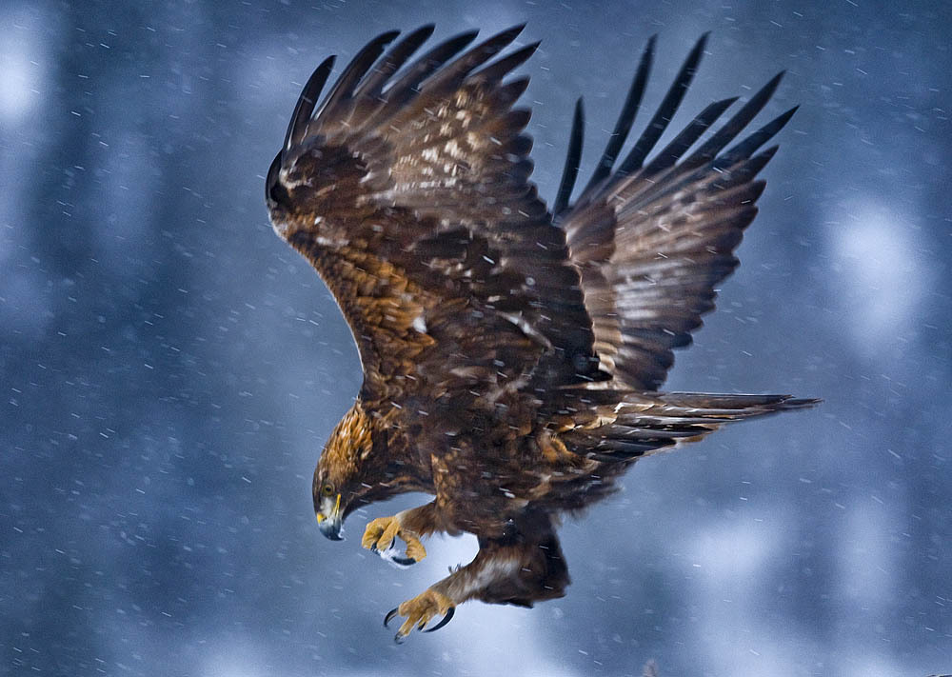
The word raptor is derived from “rapere” a Latin word which means to seize or capture. More specifically, a raptor is a bird of prey. A bird of prey is a meat eater that kills and eats mammals, reptiles, amphibians, insects, rodents as well as other birds.
Many birds hunt, kill, and eat meat, but they may not be raptors. There are three distinguishing traits that make raptors different from other birds:
- hooked beaks with sharp edges;
- feet with sharp, curved talons;
- keen eyesight.
Birds of prey include eagles, vultures, ospreys, hawks and other meat-eating birds. Like all predators they have the job of keeping the earth in balance. They eat mice, insects and other animals that would overrun the earth without them. Most birds of prey are highly intelligent and have excellent eyesight.
Источник: http://easyscienceforkids.com/all-about-birds-of-prey/

