Spectacled Bears
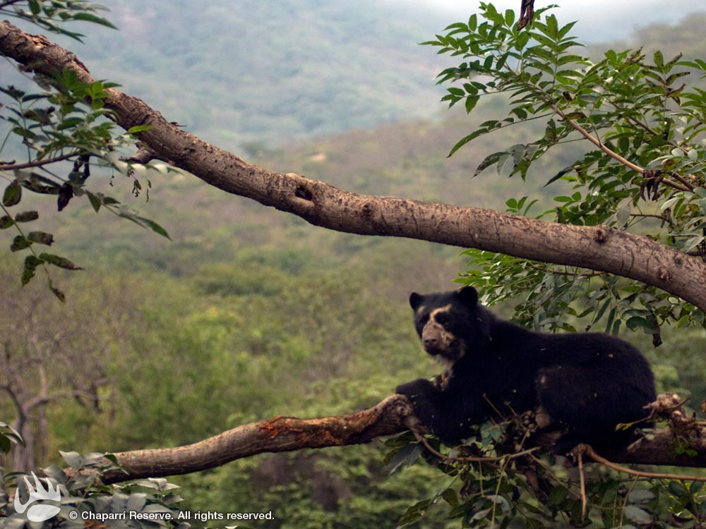
Spectacled Bears are also called Andean Bears because they are mostly found in Andes mountains of South America. This is the only kind of bear on the continent of South America. They mostly live in very thick forests. They prefer the isolated “cloud forests” high up in the Andes. Cloud forests are called that because of the fog that forms much of the time at the top part of the trees.
The spectacled bear gets its name from the whitish or yellowish marks around its eyes that make it look like it is wearing glasses, or spectacles. Each bear has slightly different markings, and some don’t have them at all, so that no two bears look exactly the same. A spectacled bear has shaggy fur that is black, brown, or sometimes reddish in colour. This kind of bear is one of the smallest of the bears. Females weigh about 82 kg, but the males are bigger, weighing about 154 kg and growing to about 1.5 metres long.
Andean bears are mostly very peaceful. They spend a lot of time on treetops just lazing around. They are excellent climbers with short but strong legs. They build huge nests made out of broken branches for sleeping and reaching out to fruits.
The spectacled bear's favorite foods are fruits and bromeliads. They also enjoy dining on berries, grasses, tree bark, honey, sugarcane and insects. If necessary, they will eat small animals like rodents, rabbits and birds. These bears do not hibernate, as their food sources are available all year round.

Источники:
http://www.rainforest-alliance.org/kids/species-profiles/spectacled-bear;
http://kidcyber.com.au/tag/facts-for-kids-about-spectacled-bear/

