Alexander Nikolayevich Scriabin
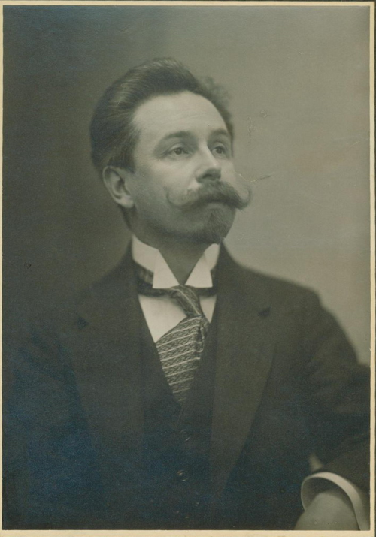
Alexander Scriabin (also spelt: Skryabin) (born Moscow January 6 1872; died Moscow April 27 1915) was a famous Russian composer and pianist.
He wrote music for the orchestra and for the piano. His music belongs to the Late Romantic period, but his later works sound quite modern, and he was influenced by Impressionism. He had some very unusual ideas about combining all the arts into one work.
Scriabin was the only child in a family which had an aristocratic background. His mother died when he was a year old and his father spent most of his time abroad working as a diplomat. He was looked after by his aunt, grandmother and great-aunt, all of whom fussed over him so that he was a very spoilt child. When he grew up he was very short and his hands could only just stretch one octave (eight notes) on the piano.
Scriabin was educated in the Moscow Cadet Corps. He learned to play the piano and became friends with the composer Sergei Rachmaninoff who was just one year younger. He won the second gold medal ever to be awarded at the Moscow Conservatoire (Rachmaninoff had won the first one). He practised a piece called Islamey by Balakirev but damaged his right hand doing it. He still managed to continue his career as a pianist, but he wrote a few piano pieces for the left hand only. In 1895 he toured through many countries in Europe giving concerts and composing a lot of piano music. He married the young pianist Vera I. Isakovich in 1897. He went with his wife to Odessa where he played his Piano Concerto and then spent several months in Paris. He taught at the Moscow Conservatoire and wrote some important orchestral music. Later he left his wife and children and went to Europe for several years with his second wife Tatiana F. Schlötzer-Skriabina (1883–1922).
She inspired a lot of his music. Scriabin continued to travel and play the piano until the end of his life. When he was in London in 1914 he had a boil on his lip, which got steadily worse until he died a year later.
Scriabin liked the music of Chopin and he wrote a lot of short pieces called Preludes which show Chopin’s influence. As he got older his music became more and more personal. He was very egocentric (thought only about himself and not about other people) and he had some strange ideas. He wanted to write a work which combined all the arts and all the senses: music, dance, poetry, colours and even smells.
He wanted this work to be performed beside a lake in India. This work was never finished or performed, and we do not know whether he seriously thought it would happen, but he did buy himself a sun helmet. Scriabin tried using different harmonies in his music. He had a favourite chord which he called his “mystic chord” (from the bottom upwards: C, F sharp, B flat, E, A, D). He used it in lots of ways.
His orchestral works include a Piano Concerto, 3 symphonies, Le poème de l’extase (The poem of extasy) and Prométhée, le poème du feu (Prometheus, the poem of fire). His music which is mysterious and dream-like and shares some similarity French Impressionist composers like Debussy.
Источник: Kids encyclopedia facts: https://kids.kiddle.co/Alexander_Scriabin.

