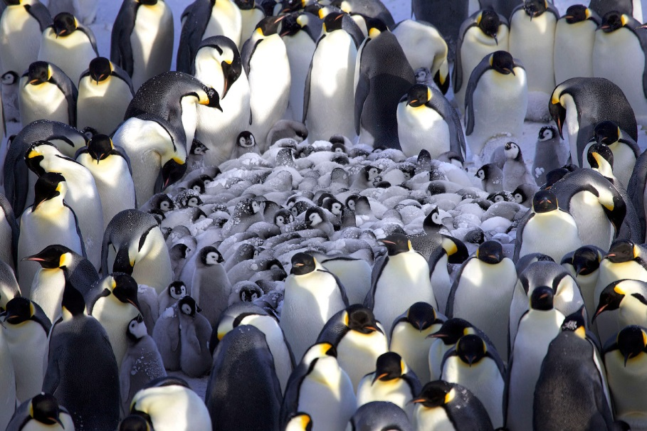
Penguins
Penguins are birds, and like other birds, they have wings and are covered with feathers. They lay eggs and are warm-blooded animals. Penguins evolved from the flying birds of more than 40 million years ago. The first penguin fossil fragments were found in New Zealand in the mid-1800s. To date, the discovery of all penguin fossil fragments has been limited to the Southern Hemisphere.
All 17 species of penguins live in the Southern Hemisphere. Penguins generally live on islands and remote continental regions that are free of land predators, where their inability to fly is not detrimental to their survival. Penguin species are found on every continent in the Southern Hemisphere. They are abundant on many temperate and sub-Antarctic islands. Different species thrive in varying climates, ranging from Galapagos penguins on tropical islands at the equator to emperor penguins restricted to the ice of Antarctica.
These highly specialized marine birds are adapted to living at sea. Some penguin species spend as much as 80% of their lives in the ocean. They usually are found near nutrient rich, cold-water currents that provide an abundant supply of food.
There are 17 different species of penguins, and they vary in size and shape. The emperor penguin is the largest of all living penguins, standing at 4 feet and weighing 90 pounds.
The smallest of the penguins is the little blue penguin, standing just 10 inches and weighing about 2.5 pounds.
Everything about a penguin is fine-tuned for swimming. Their body is rounded in the middle and pointed at either end, which is the perfect shape for sliding through water. Their powerful, flipper-like wings propel them through the ocean. Penguins are awkward on land, but their short legs and webbed feet are the perfect rudder system underwater.
And unlike other birds, penguins have solid bones. This added weight counteracts their natural buoyancy and helps them move quickly through water.
Penguins use their torpedo-shaped body to shoot through water at speeds of 15 miles per hour or more. Some penguins leap into the air while swimming − a trick known as porpoising.
Penguin legs are short and strong. Their feet are webbed, with visible claws. Penguins walk with short steps or hops, sometimes using their bills or tails to assist themselves on steep climbs. Some species, like the rockhopper, jump from rock to rock. Antarctic species can move much faster over ice by «tobogganing» on their bellies, using their flippers and feet to help them move along.
Their tuxedo-like black and white coloring is extremely effective camouflage − known as countershading − which helps them hide from predators and prey in the open ocean. For example, if a shark or other predator swims below a penguin, the penguin’s white belly blends in with the bright sunlight coming from above. Likewise, if a penguin swims below some fish it wants to catch, its black back blends in with the dark depths of the sea. Different species of penguins can be identified by their head and facial markings.
Penguins only eat seafood and swallow their food whole since they don’t have teeth. They use their powerful, hooked beaks to catch fish, squid and krill. Their tongues have a rough, Velcro-like texture that helps them hold and swallow their slippery food.
Penguins have about 80 feathers per square inch − more than any other bird. Penguins need all of those feathers to keep warm and dry. The fluffy down at the base of each feather traps air near the penguin’s skin. This air layer helps penguins keep warm, even in cold air and frigid water. When penguins are too warm, they fluff their feathers to release extra body heat.
The outer tip of each feather is stiff and small. Every feather tip overlaps with those around it, like shingles on a roof. This is what keeps penguins dry in the ocean. The tips of the feathers get wet, but the fluffy down stays dry and warm.
Penguins replace their feathers, or molt, once a year. Every year during a two to three week period, they shed their feathers and grow a complete new set. This means penguins have to keep their feathers healthy for a whole year. Because of this, most penguins spend hours every day taking care of their feathers, a behavior known as grooming or preening. A grooming penguin first cleans each feather, removing dirt and water. Then it conditions the feathers by spreading out oil from a gland at the base of its tail.

Источник: http://www.neaq.org/wp-content/uploads/2016/06/LEARN_3-5-2_Penguin_TeacherGuide.pdf

