WORKSHEET 1
Before you visit the first level of the museum do some tasks.
Task 1
- Answer the question:
Are there any architectural, sculptural or other indications of the type of objects displayed inside? What are they?
________________________________________________________________________________________________________________________________________________________________________________________________________________________________________________________________________________
- What kind of museum is the State Darwin Museum?
Tick the right variant and give the definition of this museum:
 | Art museum |  | History museum |  | Natural history museum
 | Maritime museum |  | Virtual museum |  | Historic house museum
____________________________________________________________________________________________________________________________________________________________________________________________________________________________________________________________________________________________________________________________________________________

Today you are going to take a tour of The State Darwin Museum. You will have to complete different tasks to guess a secret word at the end of the lesson. For unfamiliar words you may consult the Active vocabulary list.

Task 2
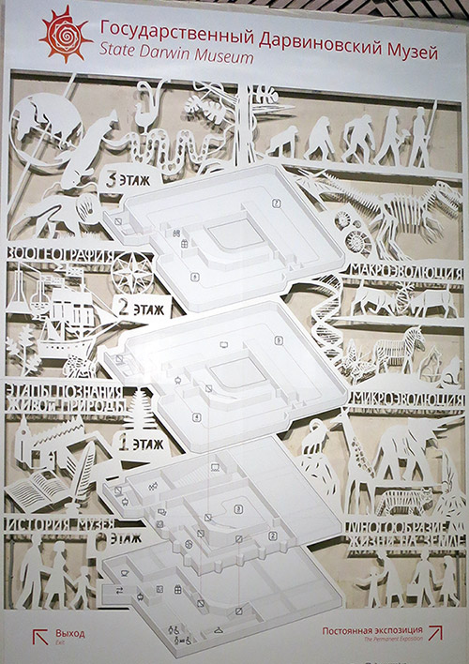
Study the map of the museum and answer the questions.

- How many levels are there in the museum?
- Which level can you learn about the history of the museum?
- Which level can you learn about the evolution of people?

Task 3

When we visit museums and exhibition halls we can move in different directions.
Read the phrases and draw the pictures.

1 | 2 | 3 | 4 | 5 | 6

- move straight ahead;
- turn left;
- move counter-clockwise;
- move back;
- turn right;
- move clockwise.

Go upstairs to the first level. Hall “The Diversity of Life on Earth”.

Task 4
You’re in the hall “The Diversity of Life on Earth”. Look around. Find these animals. Write down the names of the animals and the title of the showcase.
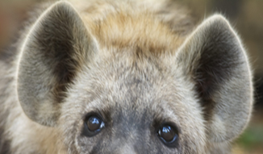 |  | 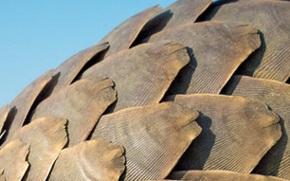 |  | 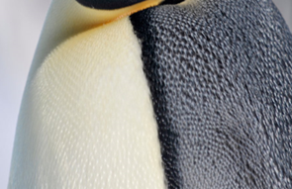
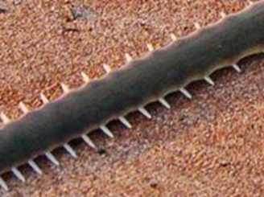 |  | 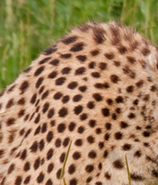 |  | 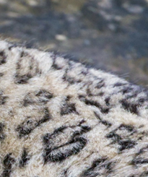
4. |  | 5. |  | 6.

Task 5
Animals speak with each other and use different sounds. Read the description and define what animal can make such a noise. Take the first letter from the sound which hyenas make to guess the secret word at the end of the lesson. It’s going to be the first letter of the secret word.

- This animal usually trumpets. It’s very big.
- This animal usually chatters and screams. It climbs and hangs on the trees.
- This animal usually neighs. It has stripes.
- This animal usually laughs. It is one of the main characters in the Lion King cartoon.

1
A __________________
B __________________
C __________________
D __________________

Task 6
Where do the animals from task 5 live? Take the second letter from the name of the continent to guess the secret word at the end of the lesson. It’s going to be the third letter of the secret word.
a. North America
3
b. Antarctica
c. Africa
d. Australia

Task 7
Circle this continent on the world map.

Task 8
Choose any showcase and describe it using the structure there is/are and the prepositions of place. Write 6–8 sentences.
Habitat _____________________
____________________________________________________________________________________________________________________________________________________________________________________________________________________________________________________________________________________________________________________________________________________________________________________________________________________________________________________________________________________________

Go upstairs to the second level. Hall “Microevolution”.
Task 9
You can see different scenes from animal lives around you. What are the following animals doing? Match the animals with the action.
The eagle are fighting with the elk.
The wolves are carrying the leaves.
The ants is attacking the hare.
What tense is used in these sentences? What else do eagles, wolves, elks and ants usually do?
____________________________________________________________________________________________________________________________________________________________________________________
What is the difference between Present Simple and Present Continuous?
____________________________________________________________________________________________________________________________________________________________________________________
Task 10
Look at the walls. There are many pictures on this floor.
a. Tick the pictures that are NOT from this floor.
b. Write one sentence to describe what is going on in each picture. We describe pictures in Present Continuous.
For example: The rabbit is playing on the grass.
c. Which of these pictures has the following names: “A farmer tending his animals”, “A lion attacking a horse”?
d. Give a name to each picture in the table by taking out the form of the verb “to be”.
Picture | Tick | Description
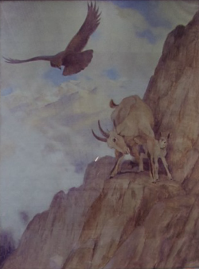
1.

 |  | Name
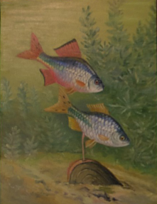
2.

 |  | Name
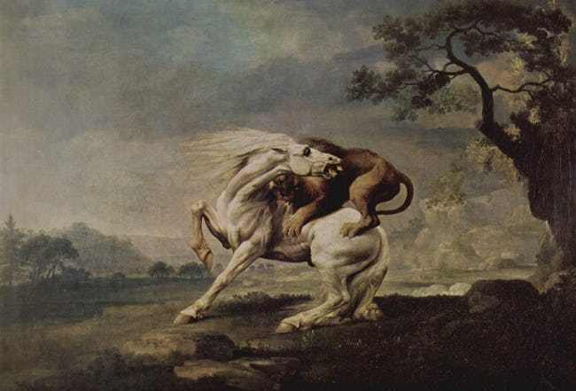
3.

 |  | Name
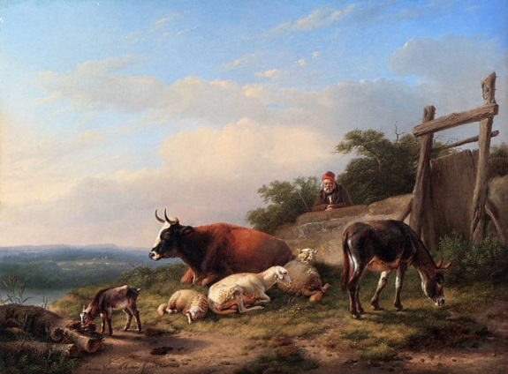  4. |  | A farmer tending his animals
 |  | Name
5.
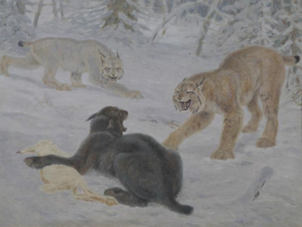

 |  | Name

Go upstairs to the third level. Hall “Macroevolution”.
Task 11
- Mark this showcase on the plan.

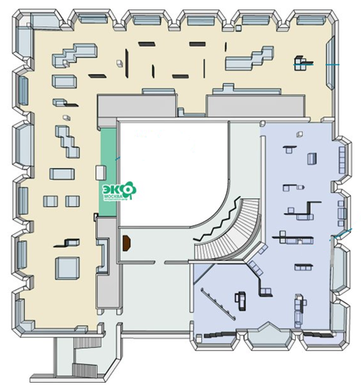
Scan the information on the showcase window. There are some facts about the fauna in the flats.
b. Use the table to guess the names of the insects that can live in the flats. The names are given in two languages (in English and Russian). Some letters are missing. You may use the Active vocabulary if needed.
 | PICTURE | TICK |  | NAME
1 | 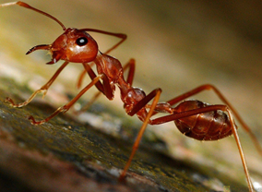 |  | A | _O_Q_IT_
 |  |  |  | _О_АР
2 | 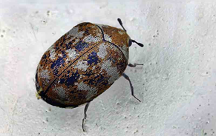 |  | B | _EN_IPE_E
 |  |  |  | С_Р_КО_О_КА
3 | 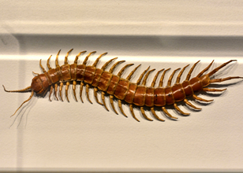 |  | C | BE_TL_
 |  |  |  | _УК
4 | 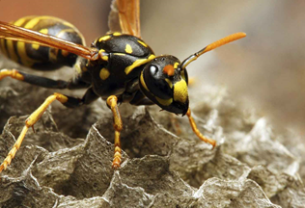 |  | D | A_T
 |  |  |  | МУР_ _ЕЙ
5 | 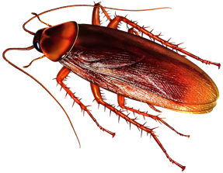 |  | E | FL_
 |  |  |  | М_Х_
6 | 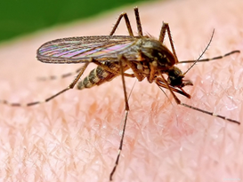 |  | F | W_SP
 |  |  |  | О_А
7 | 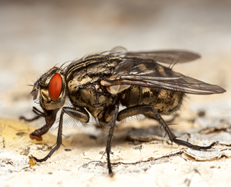 |  | G | CO_KRO_CH
 |  |  |  | ТА_ _КАН

c. Match the names of the insects with the proper pictures.
A | B | C | D | E | F | G

d. Tick the insects in the middle column, which are not described on the showcase window.

Which animal is not an insect? Take the fifth letter from the name of this insect to guess the secret word at the end of the lesson. It’s going to be the second letter of the secret word.
2

_______________________

Task 12
- What words do you associate with the word DINOSAUR? Fill in the mental map.
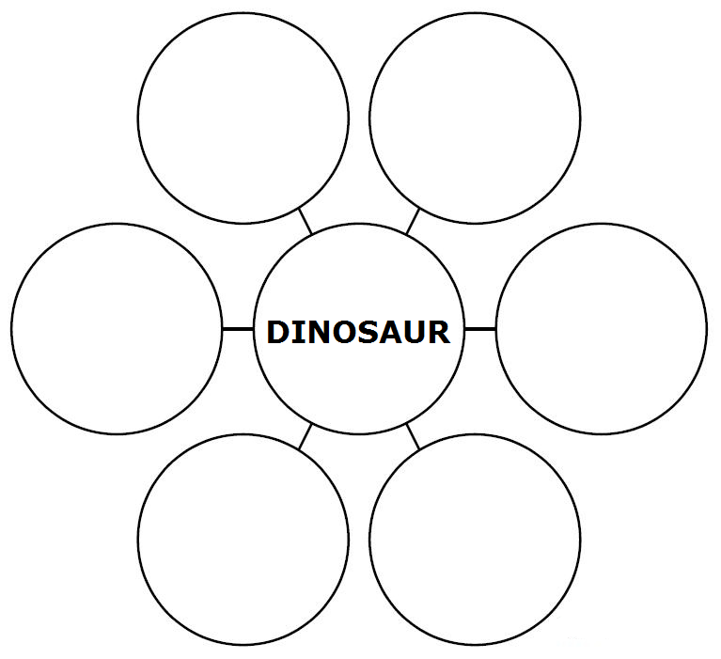
- Find the dinosaur’s skeleton shown in the picture in the hall.

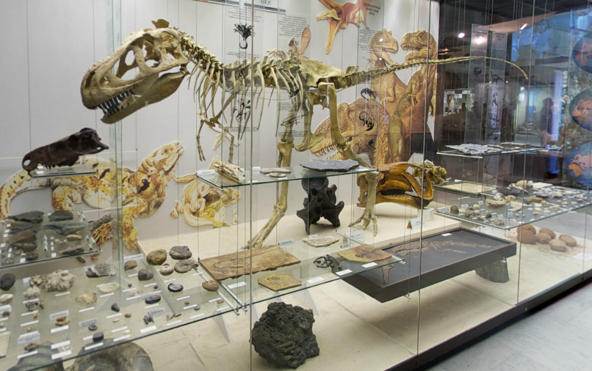

Write down the number of the showcase. ___________________________________________________________

c. Choose the right names for the dinosaurs in the picture. Some of the letters in the names are missing.

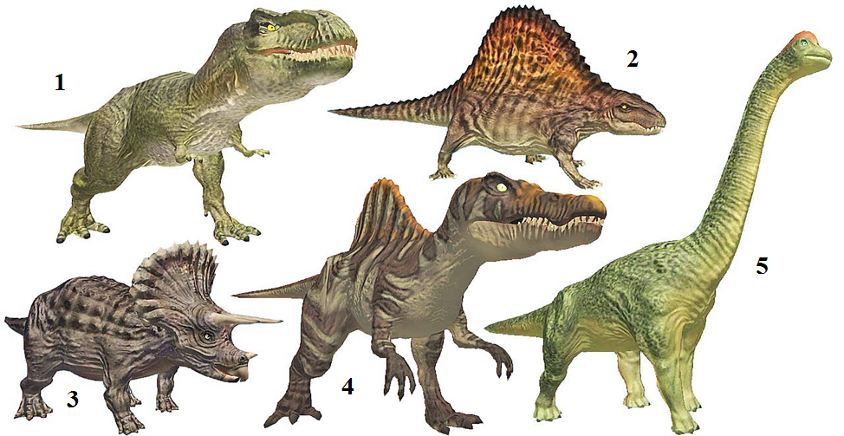

BRONTOSAURUS STEGOSAURUS
TYRANNOSAURUS SPINOSAURUS TRICERATOPS

Which of these dinosaurs can you see in the showcases? Tick the right picture.

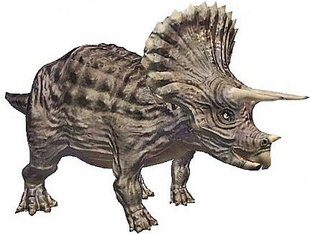
Take the fifth letter from the name of this dinosaur to guess the secret word at the end of the lesson. It’s going to be the fifth letter of the secret word.
__ __ __ __ __ __ __ __ __ __ __
4

Task 13
Now the time has come to guess the secret word. Look through the papers once again and fill in the missing letters.
L | I | F | E

Task 14
Complete a letter to your English-speaking friend about your visit to the State Darwin museum.
Moscow
Russia
02 September, 20…

Dear … ,
Thank you for your letter! I’m sorry I haven’t written for a long time. I have got good news. My classmates and I went to the State Darwin museum. It is a natural history museum.
It was very interesting to know about……………………………………………
……………………………………………………………………………………………………………………………………………………………………………………………………………………………………………………………………………………………………………………………………………………………………………………………………………………………………………………………………………………………………………………………………………………………………………………………………………………………………….
I enjoyed the time very much.
Do you go to the museums? Which museum in your city do you like most of all? When did you go to the museum last time?
Please, write back soon!
Best wishes,
………….

