Rain Forests
Влажные тропические леса

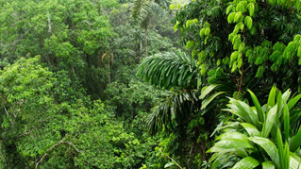
A rainforest is a thick forest of plants that stay green year-round. It has the greatest variety of plants and animals. Tropical places are warm and wet. There are tropical rainforests in many places around the world close to the equator. The Amazon rainforest is in South America and it is the largest tropical rainforest on Earth. The Amazon rainforest is very dense (густой). It’s hot and very humid (влажный) here. The temperature is always very warm, and it rains heavily all year long. There are between eighty and two hundred forty inches of rainfall (осадки) here every year. That makes this one of the wettest places you can find on land.
There are also many different kinds of animals that call the Amazon rainforest home. Many types of interesting and colorful birds, frogs, insects, reptiles, and other animals live in the trees and other plants of the tropical rainforest. These huge toucans (тукан) use their large beaks to cut fruit from branches and to eat lizards, as well as other birds. Macaws, which are a kind of parrot, travel in groups and use their hooked beaks to break into hard nuts and fruits. And you don’t want to get too close to the poison arrow frog, which has poisonous skin to protect it from its predators
(хищник).

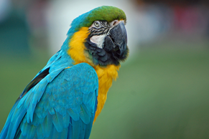 |  | 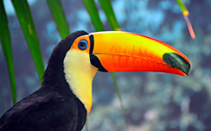 |  | 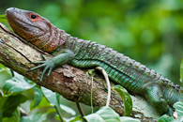 |  | 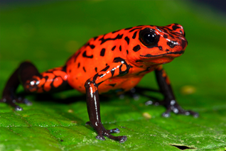
Macaw |  | Toucan |  | Lizard |  | Poison arrow frog
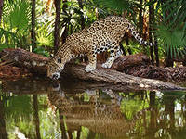
Jaguars are very well adapted to living in the rainforest. They have very sensitive hearing and an excellent sense of smell. A jaguar can see very well during the day and at night. All these things make it easier for it to find food and catch small animals.
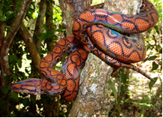
Wow, look at the size of this snake! It’s a boa constrictor, one of many kinds of snakes that live in the Amazon rainforest. It’s a pretty big snake; this one is about 4 meters long! Boas can have slightly different coloring and patterns on their skin, but they are well camouflaged in the trees, plants, and vines of the forest.

Источник: «Animals and Habitats. Tell It Again!™ Read-Aloud Anthology»
New York, 1995

