The Arctic tundra

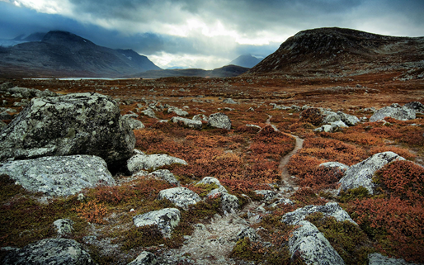
In the Arctic tundra there aren’t very many plants.
The wind here is very strong, it makes the air feel even colder. The ground is frozen and nearly everything is covered in ice. In winter daylight lasts only a few hours, and at times the sun does not come out at all. In summer the top layer of ice melts so that the ground gets wet and muddy. The temperatures here are low. All of these things make the Arctic tundra one of the least friendly habitats on Earth for plants and animals.
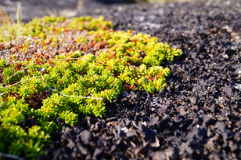
Some plants and animals can only live in the Arctic tundra in the summer months when the temperature is warmer, but some are able to live there all year long. Arctic plants grow very close together and do not grow very tall, it keeps them from being blown away by the Arctic winds. The kinds of plants that can live in the Arctic tundra are mosses and different types of grasses.

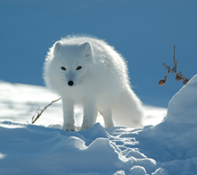
The animals that call the Arctic tundra habitat home all year round have adapted to the hard conditions. When an animal has adapted to a habitat, that means it has special things that help it lives in that habitat. For example, many animals in the Arctic have adapted by growing heavy fur coats that help them stay warm in the cold temperatures.
This Arctic fox also has a coat that changes from a brown summer coat into this very thick, white fur to help the fox blend into its surroundings. The fur also covers its feet so it can walk on snow and ice. Thanks to the fox’s fur, it can hide and sneak up on birds, hares, and rodents like me!

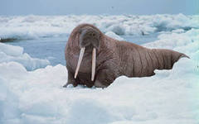
There are other kinds of habitats in the Arctic besides the tundra, and different kinds of plants and animals live in these other habitats. The Arctic Ocean is a habitat rich in sea life and animals that rely on the sea for their food. The water is so cold in the Arctic Ocean that most living creatures would be able to stay alive only a few minutes in it.
Animals such as the walrus call the Arctic Ocean home. These huge creatures just love the icy water and can swim around for a long period of time! Walruses have adapted to life in the Arctic Ocean by storing blubber under their skin. Blubber prevents heat from escaping from their bodies. Walruses also have long teeth, called tusks, which they use almost like arms to pull themselves up out of the water and onto the ice.
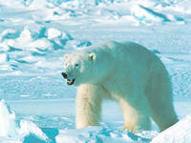
The polar bear is perhaps the best known of all the animals living around the Arctic Ocean. Polar bears are the largest bears in the world. Male polar bears weigh up to 500 kg. And polar bears grow up to 2 meters from head to toe.
Polar bears are covered with a heavy coat made up of two layers of fur, and they have a layer of blubber under their skin. Their ears and tails are very small so that not too much of their bodies are exposed to the cold weather. It’s a good thing they have all that fur and blubber and sharp claws, because polar bears spend most of their life living on sea ice, chunks of ice that float in the Arctic Ocean. Sometimes polar bears dive in the icy Arctic water to swim from one chunk of ice to another, and they have webbed paws, sort of like a duck’s feet, to help them swim.
They use those mighty paws to hunt their favorite food – seals. Like all living things, polar bears need water to survive, and they get that water from melted snow and ice.

Источник: «Animals and Habitats. Tell It Again!™ Read-Aloud Anthology»
New York 1995

