Alexander Scriabin
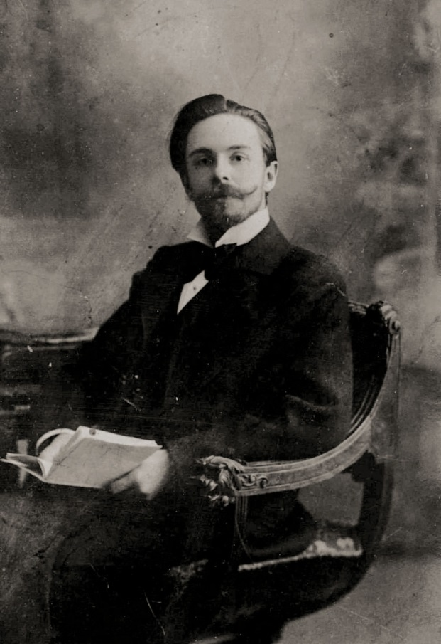
Alexander Scriabin was a Russian composer and pianist who invented the first colour keyboard and notation for lights and colors based on his scale of Synesthetic colors. His symphony 'Prometheus: The Poem of Fire' (1910) was the first composition in history which included notation for lights and colors. Scriabin's large-scale performances in Moscow and New York were the first live shows ever with lights and colors played on a colour keyboard and projected to the beat and harmony of his music, thus preceding modern day rock concerts.
Alexander Nikolayevich Scriabin was born on January 6, 1872, (old calendar date December 25, 1871, the Russian Orthodox Christmas), in Moscow, Russia. His father, named Nikolai Scriabin, was a wealthy aristocrat, a lawyer, and a ranking diplomat, who lived mostly in the Russian embassies abroad. His mother, named Lyubov Petrovna, was a professional pianist; she died when Scriabin was only one year old. Young Scriabin was brought up by his aunt, and played his first music on his late mother's piano.
His first piano teacher was Nikolai Zverev who was also teaching Sergei Vasilyevich Rachmaninoff at the same time, and two composers developed a life-long friendship. From 1882–1889 he studied sciences and languages at the Moscow School of Cadets. From 1888–1892 Scriabin studied piano and composition under 'Sergei Taneyev' at Moscow Conservatory, graduating in 1892, as composer and pianist, then he became a professor at the same conservatory. In 1896 Scriabin married a famous Russian pianist, Vera Isakovich, who was the winner of the Gold Medal for performances of Scriabin's piano music. Before 1900 Scriabin joined the Moscow Philosophic Society and studied various schools of thought in his pursuit of inspirational ideas.
From 1904–1910 Scriabin was living and concertizing in Western Europe and in the United States. He was a remarkable pianist and successfully performed his original compositions before international audiences. At that time Scriabin became a curious student of contemporary philosophic trends and literature. His readings ranged from Oriental philosophies and Metaphysics, to Friedrich Wilhelm Nietzsche, whose 'ubermensch' theory Scriabin eventually outgrew, to Astrology and Medicine, and to Sir Isaac Newton's 'Optics'. He joined the circle of the Belgian Symbolist and Occultist Jean Delwille in Brussels. Scriabin also entered the circle of late Helene Blavatsky in London, studied her Theosophy, and even visited the room where she died. Scriabin's search for inspiration was not limited to Mysticism, Astrology and other Esoteric writings of the time. From 1907–1910 Scriabin lived in Paris with his second wife, Tatiana Schletser. There he was involved in the circle of Sergei Pavlovich Diaghilev and provided his compositions for concerts of Russian music.
Scriabin was gifted with synaesthetic ability, though probably different from that of the physiological gift of Wassily Kandinsky, or a cognate cross-sensational gift of Vladimir Nabokov. Scriabin was the first composer in the world who wrote the musical notation for the light and color, thus making color intertwined with sound in a cross-senses harmony. In his symphonic poem 'Prometheus: the Poem of Fire' (1909) he wrote the line with notation for 'Luxe', a specially designed multicolor light projector with colored light-bulbs which was controlled by Scriabin himself playing on a colour keyboard. The multi-colored keyboard was first built in Russia by physicist Alexander Moser in 1910 for the performances of 'Prometheus'. Its performances in Moscow and in New York were the first ever orchestral concerts with color accompaniment being projected on a special screen. Scriabin also experimented with such styles as musical impressionism and expressionism. His harmonic and melodic inventiveness became manifested in his piano works and especially in his orchestral compositions. The 'Prometheus' chord' was the beginning in Scriabin's search for the new tonal/harmonic means of expression. His theory of the 'Synthesis of arts' made profound effect on innovations in film and theatre, most notably those of Vsevolod Emilevich Meyerhold at the Moscow Art Theatre.
In 1915 Scriabin worked on developing of a new form of entertainment that would unite all Mankind through music, art, light, acting and interaction between performers and public. For this project Scriabin started a draft of a new cross-genre composition, which included music, literature, dance, architecture, natural landscape and light. He contemplated a seven-day long composition titled 'Misterium', of which he wrote down a few fragments on seventy pages shortly before his death. He described the composition in his draft as "a grandiose religious synthesis of all arts which would herald the birth of a New World." Scriabin planned his work to be performed at the foothills of the Himalayan mountains. Scriabin planned to include the Sunrises and the Sunsets into the measures of his unfinished music score.
Scriabin's admirer and friend poet Valery Briusov was a regular guest at Scriabin's home, where composer performed for friends and absorbed new ideas in cross-disciplinary discussions. Those discussions initially revolved around Symbolism in Art, and then eventually led to Scriabin's idea of "Future Art" or "Synthesis of Arts" alluding to a term "Gezamtkunstwerk" which was originally coined by Richard Wagner. Music and cultural heritage of other nations was among important sources of inspiration for Scriabin, who was also known as an acclaimed piano performer of music by Frédéric Chopin, Franz Liszt and Ludwig van Beethoven. Scriabin's original piano pieces show progressive development of his own tonal and harmonic thinking. His ten piano sonatas, 24 preludes, poems, études and other piano pieces are staples of many contemporary concert pianists' repertoire. The piano recordings of Scriabin's music by Vladimir Sofronitsky and Vladimir Horowitz are among the finest there are.
During the 1890s and 1900s Scriabin's evolution to multi-tonal complexities superseded calculated duodecafonic compositions of the Neo-Viennese school. From his early piano compositions to his grand-scale symphonies, Scriabin's music is peppered with harmonic innovations, unusual changes and surprise tonal discoveries. Scriabin's creative thinking invites a prepared listener to an intellectual journey beyond the calculated atonality of Arnold Schönberg or even the sophisticated cosmopolitanism of Igor Stravinsky. The asensual trajectory of Scriabin's multi-tonality development is unparalleled in freedom of musical imagination. His rich and delicate Piano Concerto in F-Sharp Minor (1896) and the passionate 'Poem of Ecstasy' (1906) has been among the most recorded and frequently performed of his orchestral works.
Alexander Scriabin was at the peak of his creativity and worked on his innovative breakthrough project of 'Mysteria', when he died of septicaemia, a complication from an inflammation on his upper lip, aged 43, on April 27, 1915, in Moscow. He was laid to rest in the Church of St. Nikolai na Peskah, near his home in Moscow, Russia. Since 1922, the Scriabin's home in Moscow has been open to public as a National museum and a Cultural Heritage Memorial. Scriabin's Bechstein grand piano has been used for regular concert performances of his music.
Since the 1910 premiere of 'Prometheus', Scriabin's large-scale symphonies has been successfully performed with light and color accompaniment at concert venues all over the world.
- IMDb Mini Biography By: Steve Shelokhonov

Источник: https://www.imdb.com/name/nm0780099/bio

