Case 1

In each box below put a photo of any animal and then write a few sentences to explain how it is suited to its environment.

Water voles

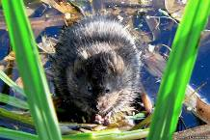

Water voles spend time on the land and in the water so their bodies have to be adapted for both environments.
Their fur is waterproof, but their feet aren’t webbed.
They have large incisors as they gnaw through a lot of plants. There is a gap between its molars and incisors which lets it gnaw things it doesn’t want to eat.

Case 2
Create a fact book about the animals you like. The fact book should be interesting to someone who doesn’t know about these animals already. It could include information about what the animal looks like, where it lives (the habitat, and the locations within it, e.g. pond margins, treetops), how it breeds, how it fits into a food chain (what it eats and is eaten by).

